Zaplify Customer Value Proposition

# Introduction

Life revolves around a set of Activities. We use our calendar to capture Activities that have regular cadences – specific days, times, and places. We use task lists to remind us of things that don’t fall neatly into our calendar. But neither of these tools allows us to organize and relate this information to the Activity. Once an appointment or task is complete, it is difficult to go back and find out what you did and how you did it: you typically have to start over.

Zaplify allows you to capture the Activities that your life revolves around – both the things you need to do and things you want to do. You can specify the cadence for these Activities – as specifically (“every Monday at 8am”) or as generally (“once every quarter”) as you like. Zaplify helps you transform Activities into Tasks and Appointments that integrate with your existing Calendar. You can associate information (people, places, links, lists, notes) with an Activity, and this information follows the Activity around as it makes its way into your Calendar and task list. Once you’ve captured an Activity and its associated information, Zaplify keeps track of when it’s time to do the Activity again, shows you all of the relevant information, and helps you schedule it.

# Examples

* **Exercise**: you want to exercise three times a week, but your busy life doesn’t always allow you to go to the gym on the same days and times. Zaplify helps you capture this intent and schedule your exercise for the week.
* **Grocery shopping**: when you do your weekly grocery shopping, you want your current grocery list easily accessible. Zaplify allows you to create a shared grocery list, schedule your grocery shopping for the week, and easily link the grocery list to your calendar appointment.
* **Haircuts**: you’d like to get your haircut once every month. Zaplify helps you schedule this month’s hair appointment and keeps all the salon’s information together.
* **Changing your oil**: you sometimes forget to change your oil every three months. Zaplify reminds you to schedule this month’s oil change, allowing you to easily call and make an appointment.
* **Cleaning the gutters**: you always forget who cleaned it last time and whether they did a good job. Zaplify stores all that information and makes it easily accessible the next time it reminds you that you need to clean the gutters.
* **Kids activities**: Zaplify helps you capture how many practices there are per week, and where and when the practices and games are happening. It allows you to capture and share contact information for other parents and helps you coordinate snack schedules and ride sharing.
* **Mother’s Day:** Zaplify keeps track of the important dates in your life and reminds you to call your mother, get her flowers, and take your spouse out to a nice dinner.

# Features

Zaplify is a FREE web application, which means you can access it from any device with a web browser.

## Gallery

Most applications make you start with a blank page. Zaplify offers a gallery of common Activities that most people tend to do, so you don’t have to start from scratch. Simply import the Categories and Activities that are relevant in your life.

## Profile

To be as useful as possible, Zaplify needs to know a little bit about you:

* Personal information such as name, address, gender, and birthday
* People in your life: marital status, spouse information, and kids information
* Things you look after: house, car, pets

Once you fill out your profile, Zaplify can filter its gallery to the things that are relevant to you.

## Calendar integration

Rather than replace your calendar, Zaplify works hand-in-hand with it – after all, you run your life out of your calendar, so integrating with what you use today is non-negotiable. To get started with Zaplify, you need to tell it about the calendar you use. Zaplify uses the privacy and security of the industry-standard OAuth2 protocol, which allows you to authorize Zaplify to access your calendar on your behalf without telling us your password. Zaplify schedules Activities onto your calendar – from the ones that you can specify precisely (dates and times) to the ones where you only know the month.

* Currently, Zaplify only supports Google Calendar. In the future, Zaplify will support Windows Live and Exchange calendars.

* In the future, Zaplify will also import recurring appointments from your calendar and allow you to associate them with new or existing Activities, to help get you up and running quicker.

## Facebook integration

Facebook already has much of the information that goes into constructing your profile. We highly recommend that you connect Zaplify to Facebook, so that we can save you all that typing. Zaplify only accesses Facebook information to complete your profile and to import the names of your friends, so that when you want to associate a person with an Activity, we can give you a nice “auto-complete” experience instead of making you type in a bunch of contacts. We use the same OAuth2 protocol to connect to Facebook, so that you can see and control what information Zaplify has access to. Importantly, Zaplify will NEVER post to Facebook on your behalf. It will NEVER spam your friends. We find apps that do this VERY annoying and the last thing we want to do is build yet another annoying app.

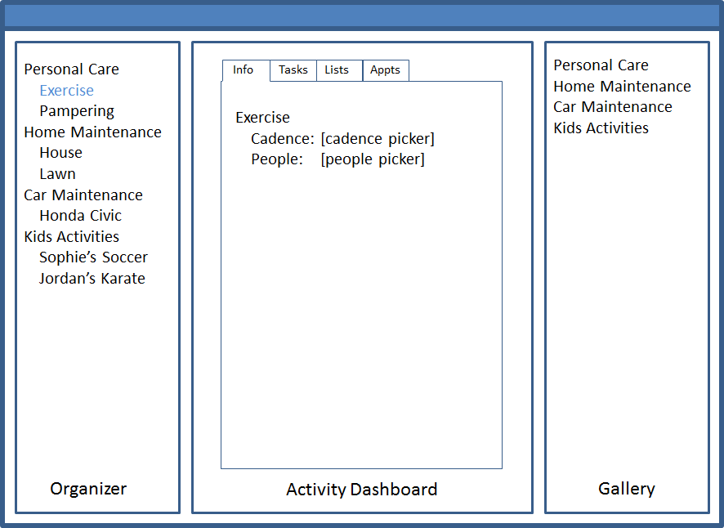

## Activity Editor

Activities are the heart of Zaplify. Whether you imported it from the gallery or created one yourself, Zaplify allows you to add and edit important information associated with the Activity:

* Cadence – how often does this Activity happen? (“Every Monday at 8am” to “once a quarter”).
* Places – where do you do this activity? (Zaplify offers a nice auto-complete experience)
* People – who do you do this with? (Zaplify offers a nice auto-complete experience for the contacts you imported and/or created)
* Lists – lists of any kind that are associated with this Activity (grocery list, equipment list)
* Notes – any freeform notes that you want to associate with the activity (last time Jordan was at the doctor, she was 4’10” and was in the 2nd percentile in height)
* Links – web links / bookmarks that you want to keep track of (website for A1 Gutter Cleaning)

## Activity Scheduler

Once you’ve created an Activity and told us its cadence, Zaplify can help you schedule it. Zaplify can show you the Activities that haven’t yet been scheduled by day, week, or month. You can then drag the instance of the Activity onto a specific day, and click a link to open your calendar and allow you to choose the time for the appointment. Zaplify allows you to schedule as many appointments as you want at a time (for example, scheduling your three workouts this week). The appointment that gets pushed to your calendar contains the places and people you’ve associated with the Activty, as well as links to all the other information, which you can easily pull up from any browser or on any mobile device.

## Organizer

The organizer allows you to categorize your Activities. The Gallery contains some preconfigured categories – Personal Care, Doctor, Shopping, Kids Activities, Car Maintenance, and so on. You can easily create new categories or sub-categories, and arrange your Activities in any order you’d like.